**HOW TO CLONE GITHUB DIRECTORY AND PUSH THE CHANGES FROM LOCAL MACHINE**

* On local machine using gitbash move to specified directory:

* Verify that your local cwd don’t have .git file

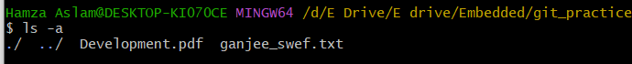

* On github create a repository

* Copy https link of rep.

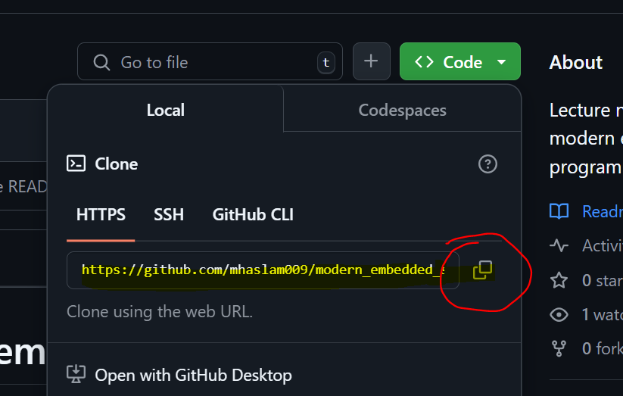

* Clone the created repo

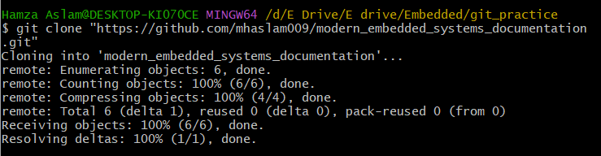

* Verify that whether u import it or not

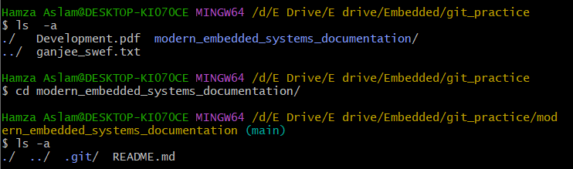

* Check the status

* Create file in **git directory==modern_embedded_systems_documentation** named specific file **password.txt**

* Check status of CWD( Current Working Directory)

* Create a files in the cloned github directory on local machine, this time using file-explorer

* Add using .

* Commit the changes with commit message

* Push to github

